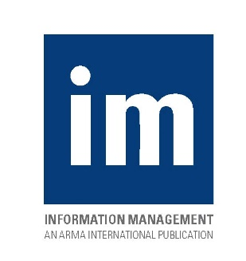
2017 Subscription Form
Volume 51, No. 1-6
Information Management (formerly Information Management Journal) is the professional business magazine for those who have responsibilities around managing records and information. It is published six times a year by ARMA International, a not-for-profit professional association and the authority on governing information as a strategic asset. Information Management’s readership includes ARMA International’s approximately 27,000 professional members worldwide, who consistently rank the magazine as one of the most valued benefits of membership. 9Learn more about ARMA International membership. Learn more at www.arma.org/r1/membership/membership-benefits.)

Information Management subscriptions are available only for the print magazine. Subscriptions are non-refundable. Claims for non-receipts must be made within six months of the issue’s publication.

Annual subscription rate: $150 non-refundable (U.S. funds)
Subscription agency discount: 15% ($127.50)
Additional shipping: $20 for destinations outside the U.S., Canada, or Puerto Rico

Subscriber Information: (Please complete all information below.)

First Name MI Last Name

Title

Organization

Street Address

City State/Province Zip/Postal Code

Country Phone

Fax E-mail
Method of Payment:
Check Enclosed (payable to ARMA International in U.S. funds)
Credit Card Visa MasterCard American Express Discover
Account # Expiration Date
Name on Card
Signature Date

Mail or fax this form to:
ARMA International
IM Subscriptions
11880 College Blvd., Suite 450
Overland Park, KS 66210
Fax: 913.341.3742

